[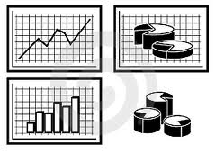](http://www.google.com/imgres?q=graphs+clipart&um=1&hl=en&safe=active&rls=com.microsoft:en-us&biw=1024&bih=587&tbm=isch&tbnid=XFLvYFbCGD_8zM:&imgrefurl=http://www.allfreelogo.com/rf-vector/2218717-graphs-and-diagrams-vector.html&docid=O5wPzB5cJTYOOM&w=300&h=214&ei=vWdyTvaGBsePsQLy18nzCQ&zoom=1)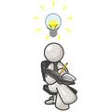[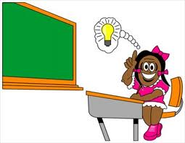](http://www.google.com/imgres?q=idea+clipart&um=1&hl=en&safe=active&rls=com.microsoft:en-us&biw=1024&bih=587&tbm=isch&tbnid=DXxiPm5Ej-uP7M:&imgrefurl=http://www.freeclipartnow.com/education/students/bright-idea.jpg.html&docid=hjWzO3xZfjI2ZM&w=350&h=272&ei=nWZyTo2tPM3MsQKk-PTBDQ&zoom=1)[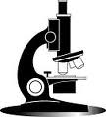](http://www.google.com/imgres?q=microscope+clipart&um=1&hl=en&safe=active&rls=com.microsoft:en-us&biw=1024&bih=587&tbm=isch&tbnid=gBCglsFeG277tM:&imgrefurl=http://classroomclipart.com/clipart/Clipart/Science/Microscope_Clipart.htm&docid=B4nN8TF2NwfNCM&w=136&h=150&ei=sWVyTtPtBM_LsQLq3Py-CQ&zoom=1)[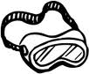](http://www.google.com/imgres?q=safety+goggles+clipart&um=1&hl=en&safe=active&sa=N&rls=com.microsoft:en-us&biw=1024&bih=587&tbm=isch&tbnid=Un-IwJVUi_PFGM:&imgrefurl=http://www.clipartpal.com/clipart/cartoon/cartoon279.html&docid=LWYXtSkyOS4rzM&w=128&h=106&ei=bWVyTsW4FtOmsQLby7XWCQ&zoom=1)j0198523

**Procedure**

(State the plan for your investigation.)

**Conclusion**

(What did you learn?

Did you answer your question?)

**Illustration**

(Show the results of your

experiment- in a table,

graph, or drawing)

**Observations & Analysis**

(What did you see during the

experiment? Did you find a pattern

in your results?)

**Materials**

(List the items you need to

conduct the experiment.)

**Hypothesis**

(Predict what you think will happen.)

**Question/Purpose**

(What do you want to learn?)

**Title**

___________________________________

**Variables**

(Independent Variable: what *you* change)

(Dependent Variable: the change that you measure)